- Name of the college: I.T.S Centre for Dental Studies & Research, Murad Nagar (DELHI-NCR)
- Details of outreach programme:

PEDIATRIC TO GERIATRIC- HOLISTIC ORAL HEALTH CARE

World Oral Health Day is celebrated to promote worldwide awareness of the issues around oral health and the importance of oral hygiene to looking after everyone old and young. The World Oral Health Day message was conveyed to the community and school children of Sultanpur Village and AashaVidyalyayIngrham School. The theme of this World Oral Health Day 2017 is “Live Mouth Smart”.
“TREATING FROM PEDIATRIC TO GERIATRIC”

It is estimated that 90% of the world’s population will suffer from oral diseases in their lifetime and many of them can be avoided with increased governmental, health association and society support and funding for prevention, detection and treatment programmes.

This Oral Health Day on 20th March 2017, I.T.S Dental College organized a Mega Camp at Village Sultanpur and AashaVidyalyayIngrham School. Two teams from the I.T.S –Centre for Dental Studies & Research conducted this program and following activities were carried out: -
SULTANPUR VILLAGE:

Series of activities were held in Sultanpur village. A team consisting of Public Health Dentists, Prosthodontists, Pedodontists, Oral Medicine, Oral Pathologists, Oral Surgeons, Physician, Physiotherapists, and eye specialists.
- Oral Screening was carried out for the community.
- Street Play, Oral Hygiene Sessions, Health Talk was carried out by the faculty member’s undergraduate students, interns for spreading awareness regarding oral health and physical health. Nukkad Natak was performed by our students to make the villagers learn about oral health and its implications in a fun yet memorable way.
- For Edentulous patients, Denture Fabrication was carried out at the venue. To care for our elderly and making them feel old age is not about compromising in any way, denture camp was specially organized in Sultanpur Village for the geriatric population to make sure they improve not only in esthetics and oral functionality but also in their self esteem.
- Preventive Procedures: Schools authorities were priorly intimated to send their wards along with parents for check-up and treatment. all kinds of preventive treatments were rendered to the school children.
- All basic dental treatment was given.
- Oral Cancer Screening and Diagnosis. - Early diagnosis procedures were conducted to diagnose oral cancer. Detection were done by oral examination and toludine blue staining procedures. Exfoliative cytological procedures were conducted on suspected cases and punch biopsies were done on suspicious leukoplakic patients. All patients were counseled on quitting harmful habits and embracing life.
- Educating Anganwadi workers: Anganwadi workers were educated on the importance of oral health so that they can impart the same to the villagers coming to them.
- Physician catered to the general health of the villagers along with BP checkup and blood sugar testing.
- Eye specialists did eye check up for the villagers. Geriatric population had complaints about their vision and many were diagnosed and suggested of cataract surgeries which they were ignorant of.
- Physiotherapy team catered both for children and adult patients. The school children were given a talk on right posture while sitting and studying, importance of outdoor games and check up of adult patients were done and appropriate exercises were prescribed.

ASHA VIDYALYAY INGRHAM SCHOOL, GHAZIABAD

Asha Vidyalyay Ingram School is located in Ghaziabad city and it caters the children with special abilities. This World Oral Health Day, team of Public Health Dentist conducted series of activities for the school children.
In addition, an Indian-Sign language for oral health was developed to educate the special children at Aasha Vidyalyay Ingrham School.
Numerous activities were carried out:
- Drawing competition
- Selfie competition
- 100-metre sprint
- Oral prophylaxis
- Preventive procedures like – Pit & fissure sealant application, APF fluoride gel application & ART
- GIC & Composite restorations
- Oral health education – using Indian Sign language (LINK - https://youtu.be/VxjrkY_Faf0)
- Brochure containing oral health instructions was also distributed

The aim of this program was to encourage school students to adopt healthy habits for future. Thus, a video demonstrating Indian sign language for oral health care was demonstrated to the students.

Take home message of this event:
- Oral Health and General Health are closely linked.
- Avoid Harmful Habits like Tobacco chewing, unhealthy diet , alcohol consumption which harms oral and physical health.
- Making the smart decisions such as adopting good oral hygiene habits, avoiding risk factors and having a regular dental check-up, they can help prevent oral disease.

- Date of the programme:20th March 2017
Place of the programme:Sultanpur Village &AashaVidyalyayIngrham School
Type of programme: Preventive, Promotive & Curative Outreach Program

SULTANPUR VILLAGE

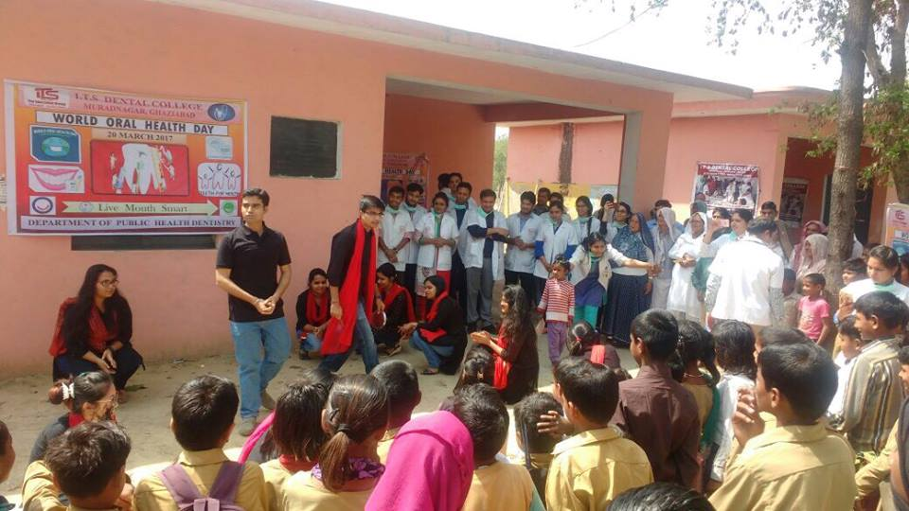
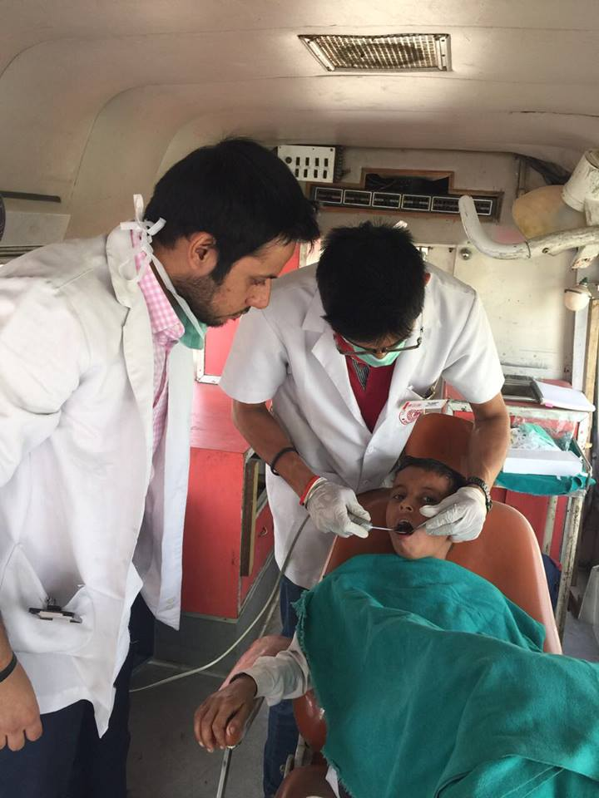

STREET PLAY PREVENTIVE PROCEDURES

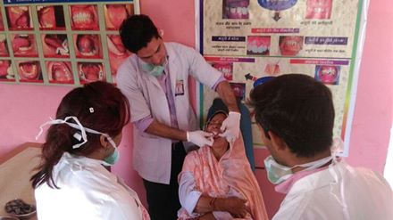
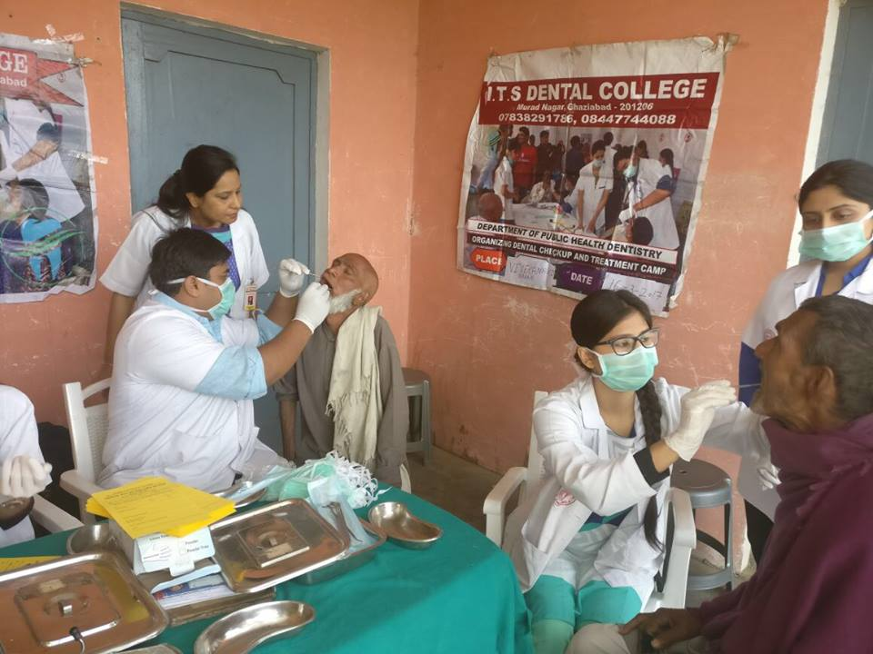

DENTURE FABRICATION ORAL SCREENING

AASHA VIDYALYAY INGRHAM SCHOOL – GHAZIABAD CITY

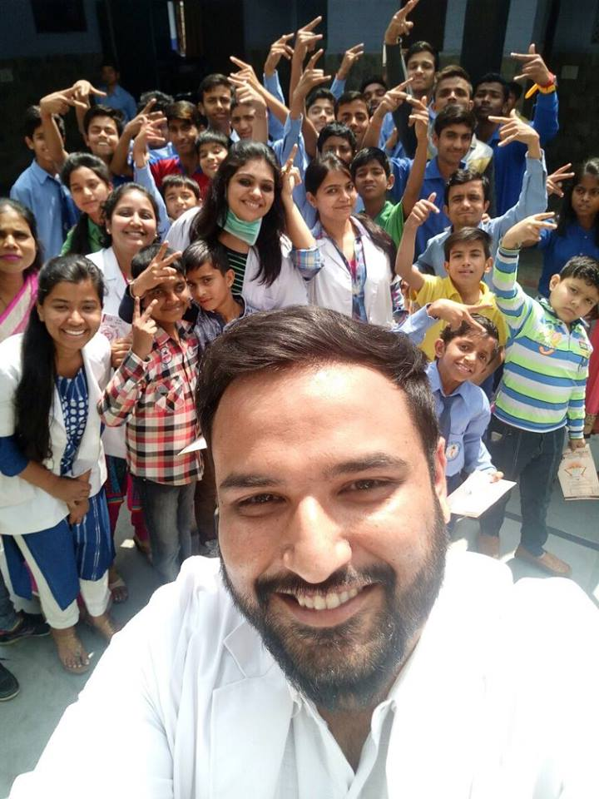
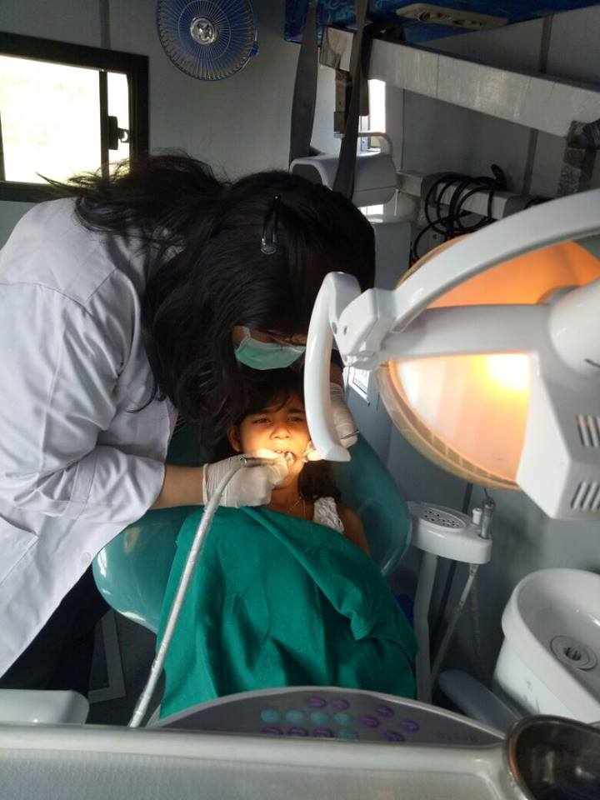

SELFIE COMPETETION PREVENTIVE PROCEDURES

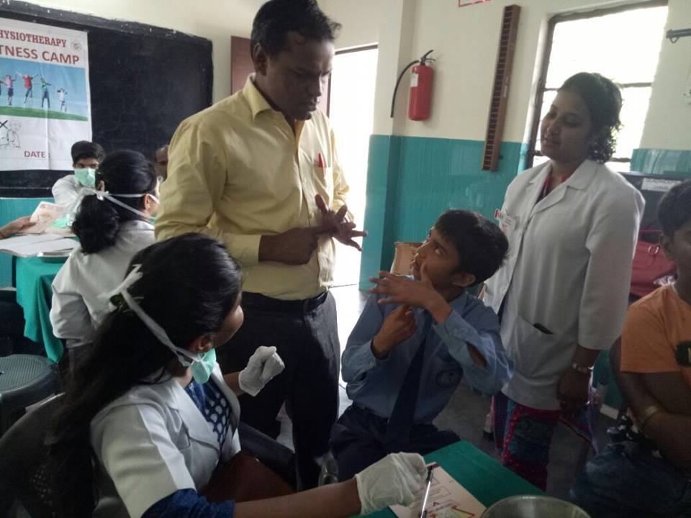
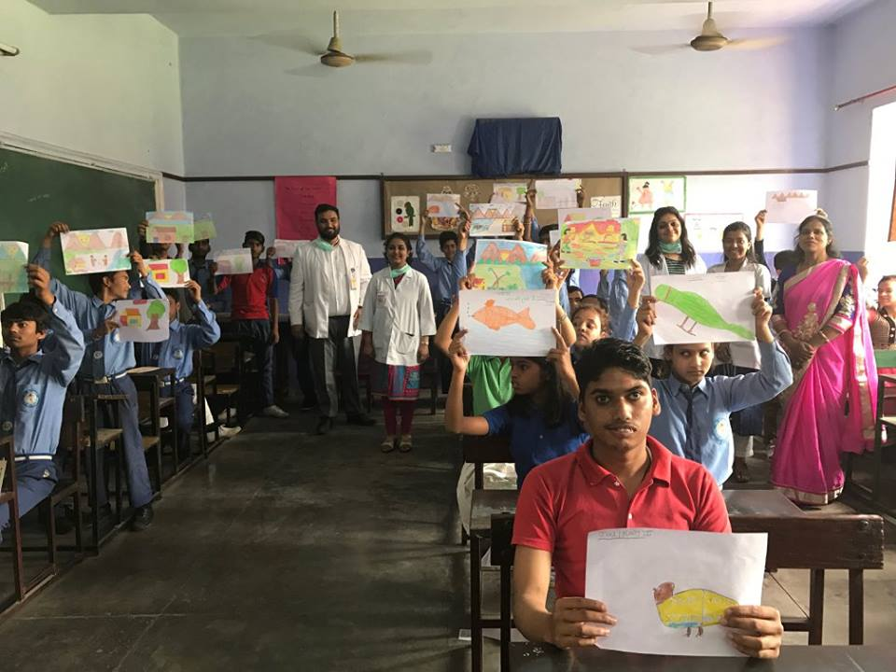

SIGN LANGUAGE INTERPRETATION DRAWING COMPETETION

INDIAN SIGN LANGUAGE FOR ORAL HEALTH EDUCATION

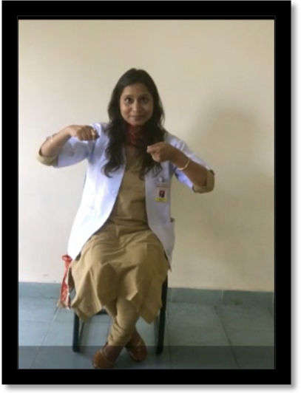
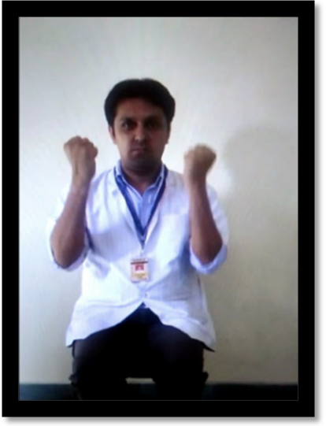

BRUSH EVERYDAY HEALTHY DIET FOR STRONGER TEETH

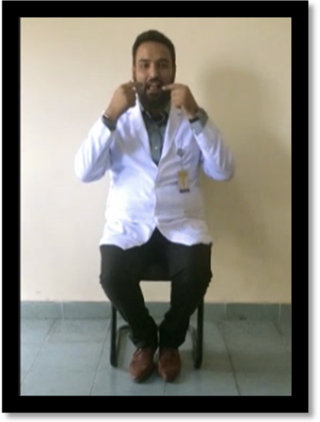
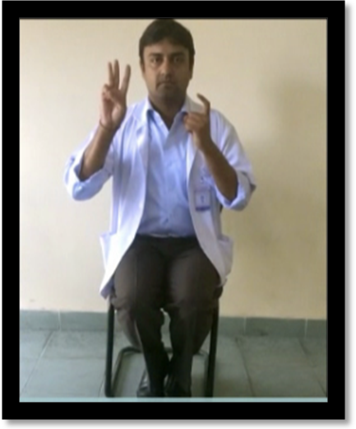

USE DENTAL FLOSS CHANGE TOOTH BRUSH EVERY 3 MONTHS
BROCHURE FOR ORAL HEALTH GUIDELINES
